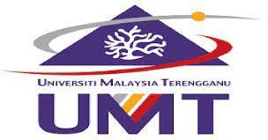

NATIVE MOBILE PROGRAMMING (CSM 3505)

Report Lab 6

**Lecturer : Dr. Rabiei Mamat**

**Demonstrator : Dr. Rabiei Mamat**

Programme : Computer Science (Software Engineering) K1

Name : SIEW KING SAM

Matric : S62270

Date : 26/12/2022

Badges

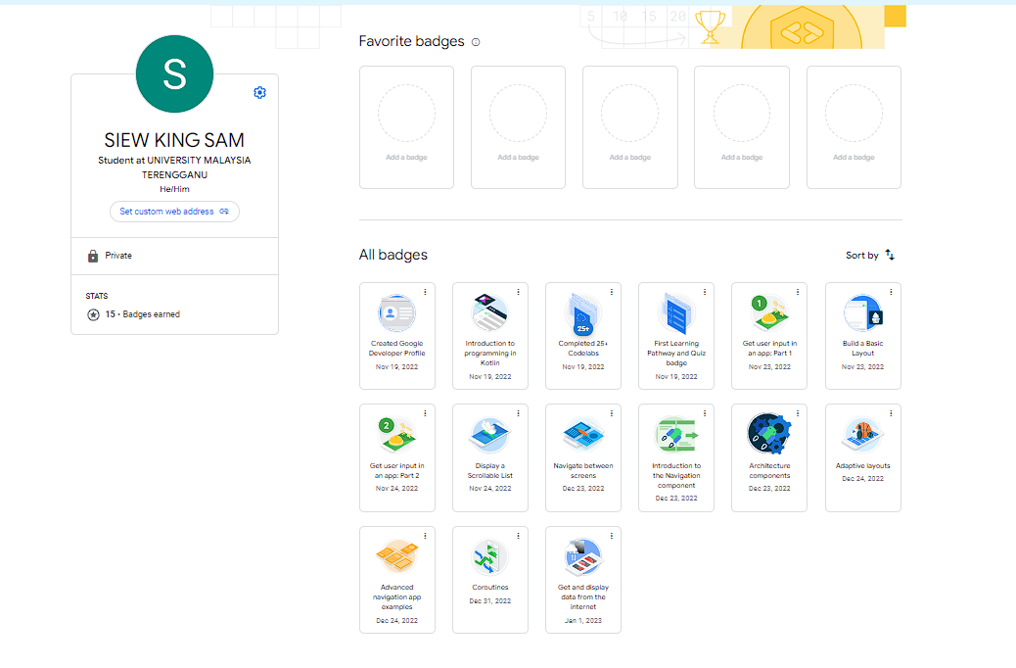

Result of the quiz

Pathway 1

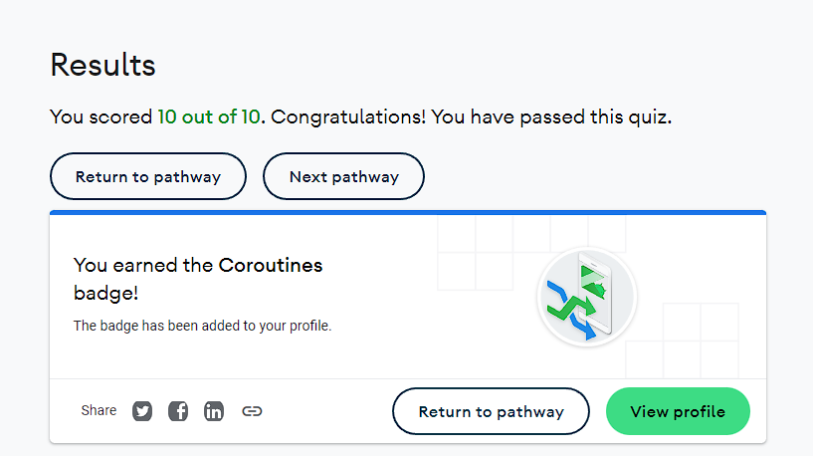

Pathway 2

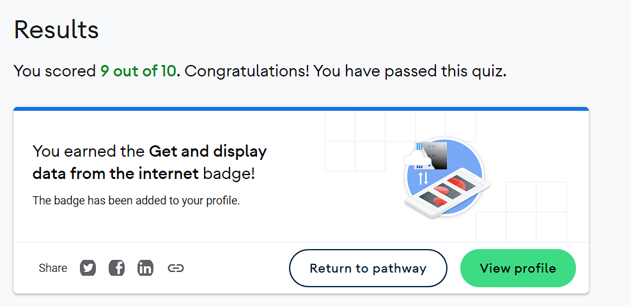

GitHub Links

Link to the Lab folder

<https://github.com/S62270/S62270_lab6>

Pathway 1

<https://github.com/S62270/S62270_lab6/tree/main/pathway%201>

Pathway 2

Activity 2

<https://github.com/S62270/S62270_lab6/tree/main/pathway%202%20activity%202>

Activity 3

<https://github.com/S62270/S62270_lab6/tree/main/pathway%202%20activity%203>

Activity 4

<https://github.com/S62270/S62270_lab6/tree/main/pathway%202%20activity%204>

Activity 5

<https://github.com/S62270/S62270_lab6/tree/main/pathway%202%20activity%205>